Topic 9 Weather Vocabulary

Weather- the state of the atmosphere at a certain place and time
Station Model- a symbolic illustration showing the weather occurring at a given reporting station
Dew Point- the atmospheric temperature (varying according to pressure and humidity) below which water droplets begin to condense and dew can form
Relative Humidity- the amount of water vapor present in air expressed as a percentage of the amount needed for saturation at the same temperature.
Barometric Trend-
Evaporation- when liquid water turns into water vapor and enters the atmosphere
Precipitation- when liquid droplets from clouds fall to Earth’s surface
Condensation- when water vapor condenses into liquid droplets
Sling Psychrometer- instrument used to measure relative humidity
Barometer- instrument that measures air pressure
Anemometer- instrument used to measure wind speed
Dry Bulb Temperature- the temperature of air measured by a thermometer freely exposed to the air, but shielded from radiation and moisture
Wet Bulb Temperature- the temperature of a parcel of air cooled to saturation (100% relative humidity) by the evaporation of water into it
Air Mass- areas of air that have similar physical characteristics
Front- a boundary between two air masses
Isotherms- bars that connect equal points of temperature
Isobars- bars that connect equal points of pressure
Cyclone- low pressure systems that lead to severe weather (hurricanes)

Weather Basics
Where does energy for weather originate? ___________________________________________
In the United States, the general direction that weather systems move is ___________________
Why? ___________________________________________________

Station Models
What page of the ESRTs has the key to decode the station model? ______________________
The temperature and dew point are measured in degrees ____________________
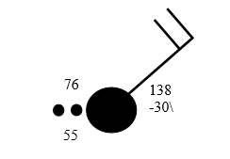
Using the station model above, fill in the chart below using your ESRTs:
Temperature | Dew Point | % Cloud  Cover | Air  Pressure | Barometric  Trend | Wind  Direction | Wind  Speed

Make sure to convert Air Pressure & Barometric Trend Numbers!
To find air pressure, you must add a decimal place between the last two digits. Then add a 9 or a 10 in front of the number so that it fits on the pressure scale on page 13 of your ESRTS.
To find the barometric trend, you must place a decimal between the two digits.

Moisture
- Evaporation- Three factors which affect it:
- ________________________________________
How does it affect evaporation? As temperature _________, rate of evaporation __________
What’s the relationship? __________________________________________
- ________________________________________
How does it affect evaporation? As surface area _________, rate of evaporation __________
What’s the relationship? __________________________________________
- ________________________________________
How does it affect evaporation? As relative humidity __________, rate of evaporation ________
What’s the relationship? __________________________________________

What natural process cleans the atmosphere? ______________________________________

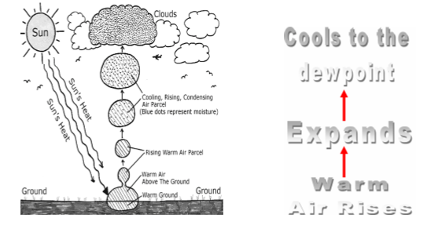

Clouds are most likely to form when:
- The air is _______________________________, and _______________________
- The temperature is at the __________________________________
- Condensation _________________________ are available for water to condense on

As the air temperature increases, the air can hold __________________ water
What instrument is used to measure relative humidity & dew point? ________________________________________________________
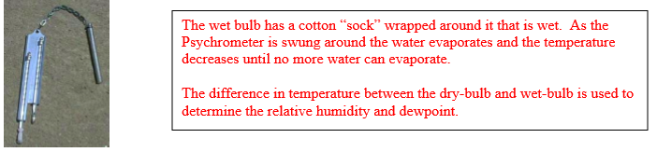
Using the charts on page 12 of the ESRTs, fill in the table values below.
Dry Bulb | Wet Bulb | Difference | Dew Point | Relative Humidity
14 | 10 | 4
20 |  | 5
30 |  |  | 19 | 55
18 |  |  |  | 56

Based on the diagram on the slide, what is the relationship between temperature and relative humidity?
As temperature goes up, relative humidity ___________________________________
An _______________________ relationship

Dew Point is a direct measure of the moisture content in the air. Therefore,
As the dew point temperature ______________, the amount of moisture in the air ____________

As the air temperature and dew point get closer together, the probability of precipitation
___________________________
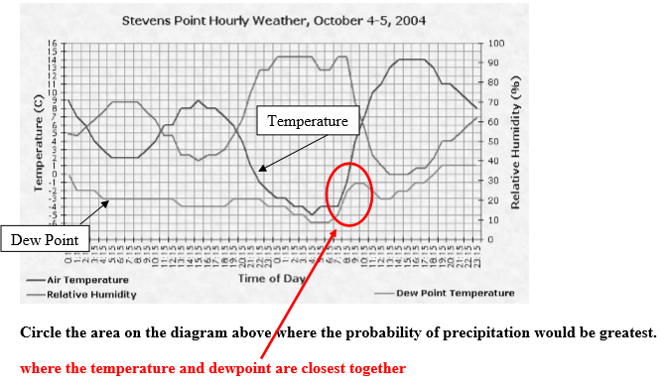

Pressure & Wind

What instrument is used to measure wind speed? ________________________________
What instrument is used to measure air pressure? ________________________________
How are winds named? ______________________________________________________
What causes wind? _________________________________________________________
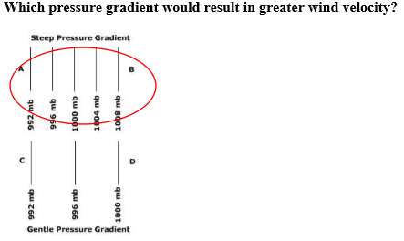
Convert the following measurements using the chart on page 13 of your ESRTs
mB | Inches of Mercury
1007
 | 29.44
1022
 | 29.35

Wind blows from areas of _______________ pressure to areas of ___________ pressure
As air pressure increases, density _______________________________

In a high pressure area, air will _________________ because the air is ___________ dense.
This is because the air is ____________ and _____________ so clouds do not form.

In a low pressure area, air will _______________ because the air is ____________ dense.
This is because the air is ____________ and _____________ so clouds are likely to form.

Direction of wind flow in the NORTHERN HEMISPHERE
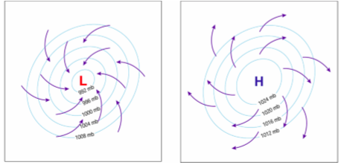
Characteristics of High and Low Pressure Areas:
 | Low Pressure | High Pressure
Warm air or cold air
Air rising or sinking
Clouds or no clouds
Clockwise or counterclockwise wind
Winds toward or away from center

On the diagrams below, label which one is a land breeze and which one is a sea breeze:
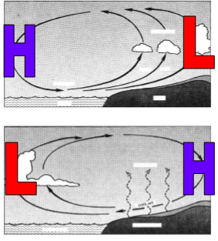
What’s the relationship between wind and waves?
The _______________ the winds, the _________________ the waves
Using the chart on page 14, state the prevailing wind direction for each latitude below:
45 degrees North ______________________
45 degrees South _____________________
75 degrees North _____________________
20 degrees North ______________________
Is air rising or sinking at the Equator? _______________________________
At 30 degrees North is air rising or sinking? _________________________

Air Masses & Fronts
Air masses are classified based on their ______________________________ and amount of
____________________________________.
Air masses get these properties based on __________________________________________.
The abbreviations they use are described in the chart below:
 | Word | Means
c
m
T
P
A

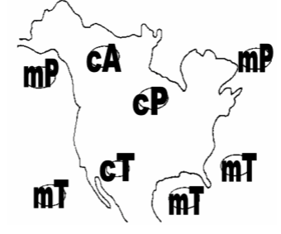
Isotherms: Points of equal _____________________________________________
Isobars: Points of equal _______________________________________________

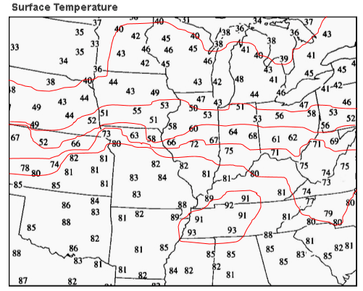

A front is a _____________________________ (interface) between air masses

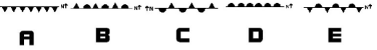
On a weather map:
Symbol A indicates a _____________ front moving ________________
Symbol B indicates an _____________________ front
Symbol C indicates a __________________ front with __________ air on the south side
Symbol D indicates a _________________ front moving _____________
Symbol E indicates a ________________ front with ___________ air on the south side

Cold Fronts
Cold fronts occur when a ___________ air mass replaces a _____________ air mass.
In a cold front, the ___________ air follows the warm air, and because ___________ are is denser, it pushes __________ air out of its way forcing ___________ air to rise.
The lifting warm air mass becomes __________________ and ______________ begin to form.
Precipitation at cold fronts are heavier although less extensive and prolonged.
The reason for this is that the uplift of warm air there is stronger due to the undercutting of cold air, so towering _______________, and __________, _________________________, __________, and ________________________ can occur.
The air behind a cold front is noticeably ___________________ and ______________ than the air ahead of it.
When the cold front passes through, temperatures can drop more than ________ in the 1st hour.
Warm Fronts
Warm fronts occur when a ___________ air mass approaches a ________________ air mass.
The warmer air ________________________ and over the colder air.
_______________ fronts are usually more gentle than ______________ fronts, move _______________, gently settling over the ____________________ and moving out of the way.
Precipitation at warm fronts are usually less heavy although more extensive than the cold fronts. The _________ behind a warm front is warmer and moister than the air ahead of it.
Warm fronts bring steadier, lighter rain or snow in __________ of them, which can last from a few hours to several days. When a warm front passes through, the _________ becomes noticeably ______________________ than it was before.
The first signs of the warm front are the ___________________________________, followed by cirrostratus, altostratus, nimbocumulus, and stratocumulus types of clouds.

Two other names for hurricanes are: _______________________ & ____________________
Hurricanes are areas of intense _____________ pressure
Which covers a greater geographic area? Hurricanes OR Tornadoes

